LAB REPORT # 05


Submitted by:

Submitted by:

Name | Registration No.
Muhammad Abdullah | FA24-BSE-042

Submitted to: Raheel Ahmed
Course: Digital Logic Design (EEE240)
Dated: MAR 15, 2026.

DEPARTMENT OF COMPUTER SCIENCE
COMSATS UNIVERSITY ISLAMABAD,
ISLAMABAD CAMPUS

In-Lab Task:
My registration numbers is 042:

Binary Conversion
Decimal 042 → Binary = 00101010
Required Function (8-bit sequence):
00101010

Truth Table
A | B | C | F
0 | 0 | 0 | 0
0 | 0 | 1 | 0
0 | 1 | 0 | 1
0 | 1 | 1 | 0
1 | 0 | 0 | 1
1 | 0 | 1 | 0
1 | 1 | 0 | 1
1 | 1 | 1 | 0

Min-terms
A | B | C | F | Min-term
0 | 0 | 0 | 0 | —
0 | 0 | 1 | 0 | —
0 | 1 | 0 | 1 | m2
0 | 1 | 1 | 0 | —
1 | 0 | 0 | 1 | m4
1 | 0 | 1 | 0 | —
1 | 1 | 0 | 1 | m6
1 | 1 | 1 | 0 | —

Sum of Products (SOP)
Min-term Expression:
F = Σm(2, 4, 6)
Expanded Form:
F = A'BC' + AB'C' + ABC'
Simplified Form:
F = C'(A + B)
Simplified expression: 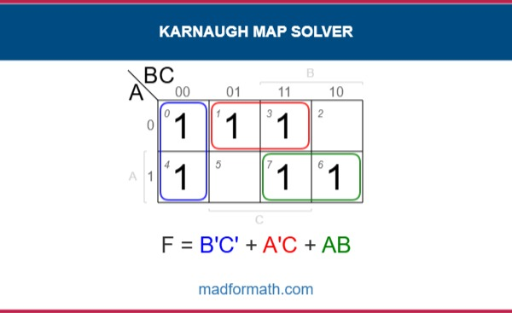
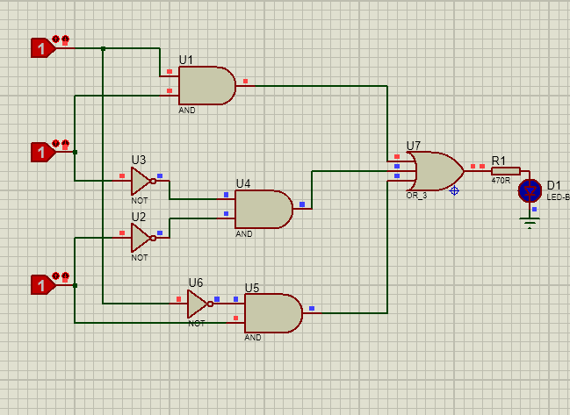

Product of Sums (POS)
F = (A + B)(C')
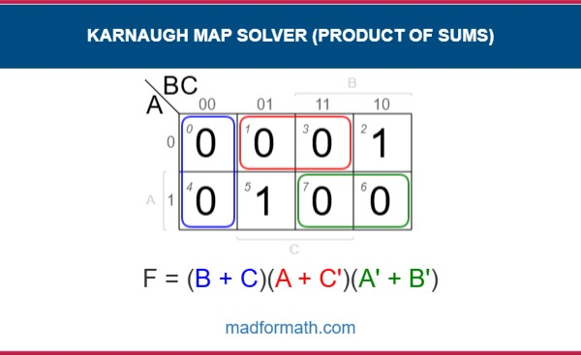
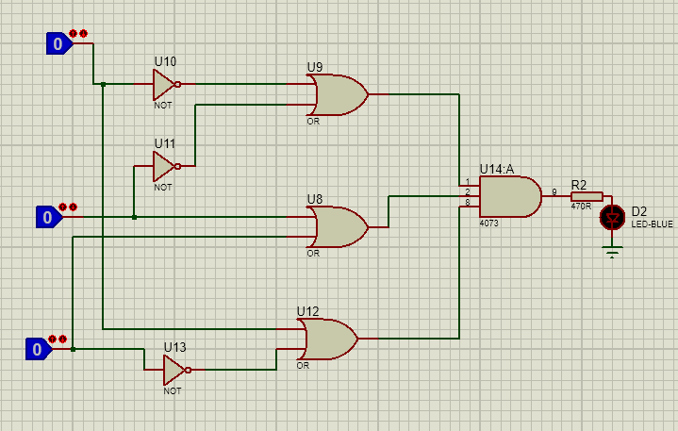

Conclusion
In this lab, the given decimal registration number 042 was converted into its binary representation and used to construct the required Boolean function. From the binary sequence 00101010, the corresponding truth table and minterm representation were derived. Based on these values, the Sum of Products (SOP) expression F = Σm(2, 4, 6) was obtained and simplified to F = C'(A + B).
The function was also expressed in Product of Sums (POS) form as F = (A + B)(C'). This experiment reinforced fundamental digital logic concepts such as binary conversion, truth table construction, minterm representation, and Boolean simplification. These techniques are essential for designing efficient and optimized digital circuits.

